SIMATS ENGINEERING
ASSESSMENT TOOL 1

COURSE NAME: INTERNET PROGRAMMING
COURSE CODE: CSA43

COURSE OUTCOME COVERED

CO-1: Develop well-structured, standards-compliant web pages using HTML/XHTML and XML, and apply Internet protocols and HTTP communication mechanisms for web content delivery. (L2)

Assessment Tool: Application-Based Questions

Weightage: 40%

QUESTIONS: Total Marks: 30

1: Online Symposium Portal
A college is developing an online symposium registration portal. The following HTML structure and HTTP interaction is observed:
<form action="/register" method="POST">
<input type="text" name="name">
<input type="email" name="email">
<button>Submit</button>
</form>
When a student submits the form, the browser sends an HTTP request to the server, and the server responds accordingly.
Questions:
Identify appropriate HTML5 semantic elements missing in the structure.
Modify the structure to make it standards-compliant.
Interpret the HTTP request generated during form submission.
Analyze the HTTP response cycle from server to browser.
Suggest improvements for usability and accessibility.
2: Cross-Browser Compatibility Issue
A company website shows inconsistent layout across browsers. The following HTML snippet is used:
<html>
<head>
<title>Company</title>
</head>
<body>
<div>
<h1>Welcome
<p>About us
</div>
</body>
</html>
Questions:
Identify improper nesting and missing closing tags.
Analyze how different browsers may interpret this structure.
Identify missing semantic elements (e.g., header, section).
Provide a corrected W3C-compliant HTML structure.
Suggest techniques to ensure cross-browser compatibility.
3: Form Submission Failure
A web application fails to send form data to the server. The following configuration is observed:
<form action="/submit" method="GET">
<input type="text" name="username">
<input type="password" name="password">
<button type="button">Login</button>
</form>
Questions:
Identify issues in the form configuration.
Analyze why the HTTP request is not triggered.
Interpret the role of GET method in this scenario.
Propose a corrected implementation.
Suggest improvements for secure data transmission.

Code of Conduct:

I ____________________ (Name / Reg No) certify that this submission is my original work and that I have adhered to the guidelines specified for this assessment.
I understand that any violation of academic integrity rules will result in disciplinary action.

Signature of the student:
1: Online Symposium Portal
A college is developing an online symposium registration portal. The following HTML
structure and HTTP interaction is observed:
&lt;form action=&quot;/register&quot; method=&quot;POST&quot;&gt;
&lt;input type=&quot;text&quot; name=&quot;name&quot;&gt;
&lt;input type=&quot;email&quot; name=&quot;email&quot;&gt;
&lt;button&gt;Submit&lt;/button&gt;
&lt;/form&gt;
When a student submits the form, the browser sends an HTTP request to the server, and the
server responds accordingly.
Questions:
1. Identify appropriate HTML5 semantic elements missing in the structure.
2. Modify the structure to make it standards-compliant.
3. Interpret the HTTP request generated during form submission.
4. Analyze the HTTP response cycle from server to browser.
5. Suggest improvements for usability and accessibility.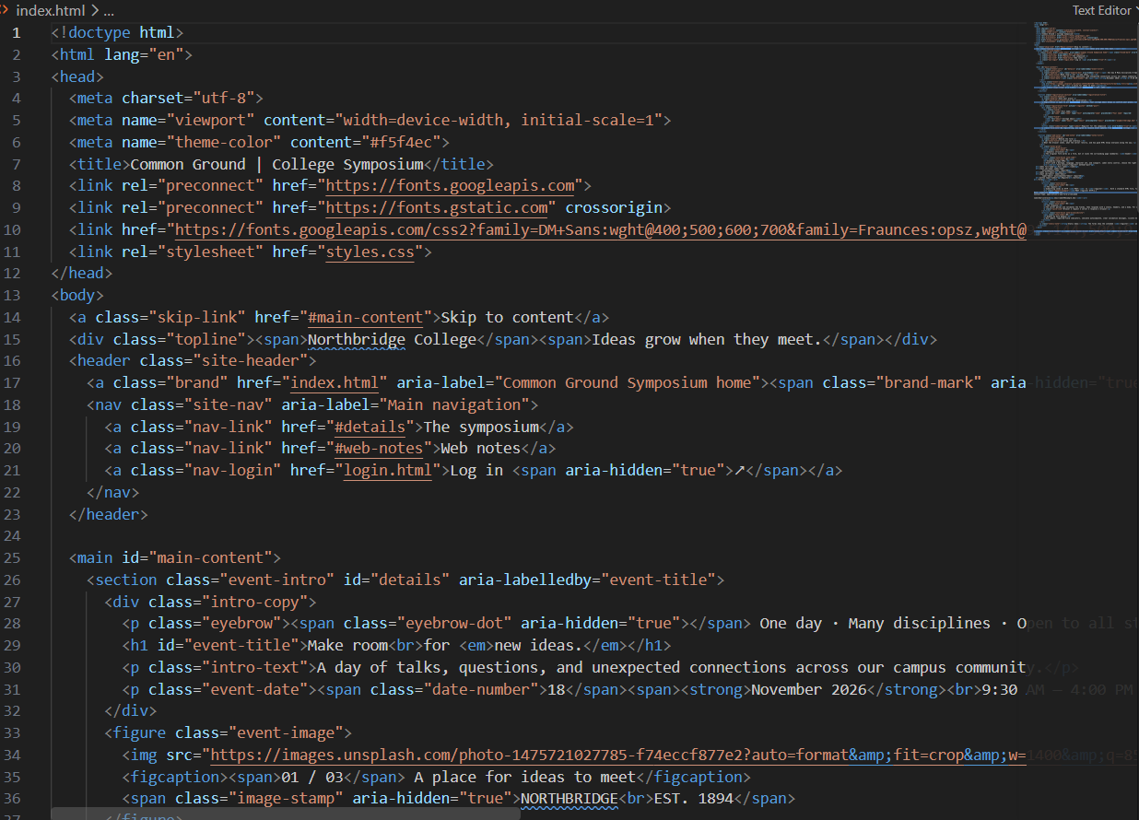


2: Cross-Browser Compatibility Issue

A company website shows inconsistent layout across browsers. The following HTML snippet
is used:
&lt;html&gt;
&lt;head&gt;
&lt;title&gt;Company&lt;/title&gt;
&lt;/head&gt;
&lt;body&gt;
&lt;div&gt;
&lt;h1&gt;Welcome
&lt;p&gt;About us
&lt;/div&gt;
&lt;/body&gt;
&lt;/html&gt;
Questions:
1. Identify improper nesting and missing closing tags.
2. Analyze how different browsers may interpret this structure.
3. Identify missing semantic elements (e.g., header, section).
4. Provide a corrected W3C-compliant HTML structure.
5. Suggest techniques to ensure cross-browser compatibility.
output:


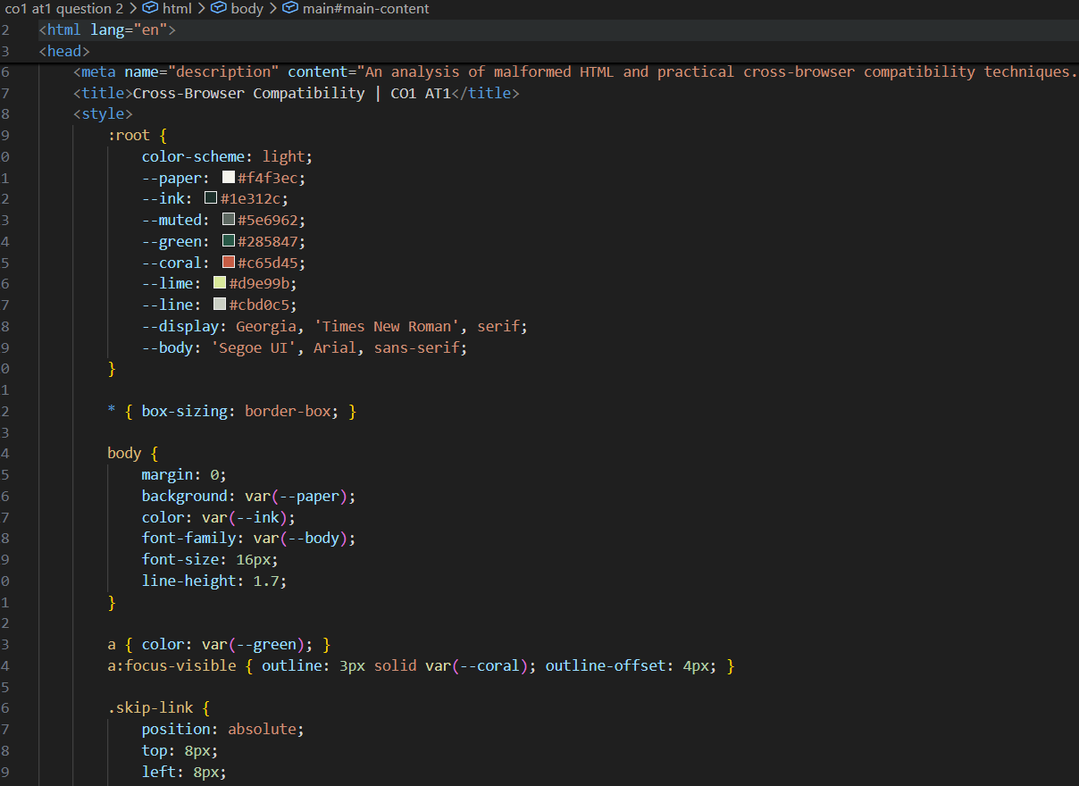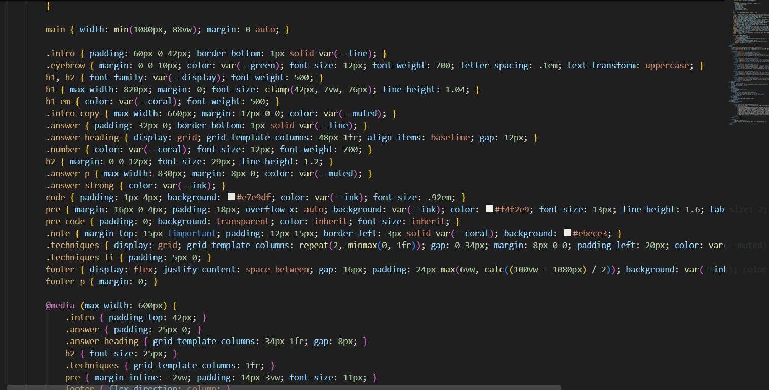
3: Form Submission Failure
A web application fails to send form data to the server. The following configuration is
observed:
&lt;form action=&quot;/submit&quot; method=&quot;GET&quot;&gt;
&lt;input type=&quot;text&quot; name=&quot;username&quot;&gt;
&lt;input type=&quot;password&quot; name=&quot;password&quot;&gt;
&lt;button type=&quot;button&quot;&gt;Login&lt;/button&gt;
&lt;/form&gt;
Questions:
1. Identify issues in the form configuration.
2. Analyze why the HTTP request is not triggered.
3. Interpret the role of GET method in this scenario.
4. Propose a corrected implementation.
5. Suggest improvements for secure data transmission.
Output:
